The Activeworlds Browser:
The picture below demonstrates what our multi-user 3D interactive chat environment looks like. You can explore the virtual world, chat to people present in the world, and view web pages all at the same time.
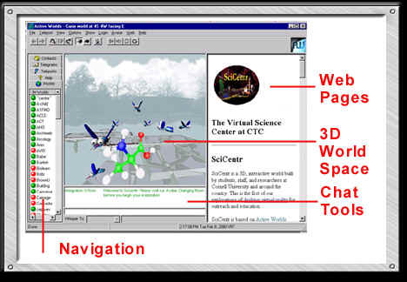

Navigating:
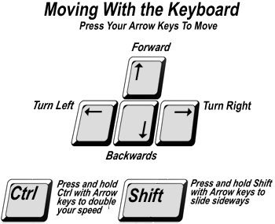 | + (plus) key – use this to fly, it moves you up in the air  - (minus) key – this moves you back down to the ground  Page up/ Page down keys – these allow you to look up or down.  Shift key – in addition to sliding sideways, press and hold shift to move through objects.

Gravity and Flying:
Gravity keeps your feet on the ground until you choose to fly. You can fly by pressing the + (plus) key on the numeric keypad. Press the – (minus) key to return to the ground and make gravity work again. Note that on laptop computers, without numeric keypads, the + and – keys are usually accessible via a combination of a function key and some other key on the laptop.
Note that when you’re flying, you’ll coast more and won’t have as much drag as you do on the ground. If you find yourself coasting too far, press the “5” key in the center of the numeric keypad to come to a complete stop.

Chatting:
Chatting in Activeworlds is similar to using any instant messenger service. To chat, type into the blank box, hit enter, and your words will come up in the chat box. Everyone in the world will be able to see what you have written.
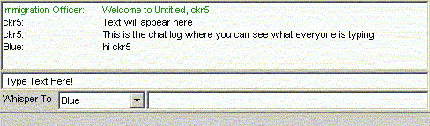

Whispering:
Whispering allows you to speak to one person in the world without anyone else seeing what you have written. To whisper click on the person's avatar name from the menu on the left, then type your message in the box to the right of this. Your message will appear in blue italics only on your screen and the recipient’s.
